Business Plan for GrandChub: An Online Community for Grandparents
"Connecting Generations, Enriching Lives"

1. Executive Summary
Business Name: Grandhub
Mission: To empower grandparents with a supportive online community that fosters connections, shares resources, and celebrates intergenerational bonds.
Vision: Become the leading global platform for grandparents seeking meaningful engagement and lifelong learning.
Objectives (Year 1):
- Acquire 10,000 free members and 500 premium subscribers.
- Achieve 70% monthly active user retention.
- Generate $60,000 in revenue through premium tiers, ads, and partnerships.

2. Market Analysis
Target Audience:
- Grandparents aged 50+ (primary), adult children (secondary for referrals).
- Tech-savvy users interested in family, hobbies, health, and legacy-building.
Market Size:
- 70 million grandparents in the U.S. alone; 58% use social media daily.
Competitors:
- General platforms (Facebook, Instagram) and niche sites (Grandparents.com).
- Differentiation: Curated content, exclusive grandparent-focused events, and tiered support.

3. Business Model: Freemium Structure
Free Tier Features:
- Access to forums, basic articles, and 1 monthly virtual event (e.g., storytelling hour).
- Limited ads.
Premium Tiers:
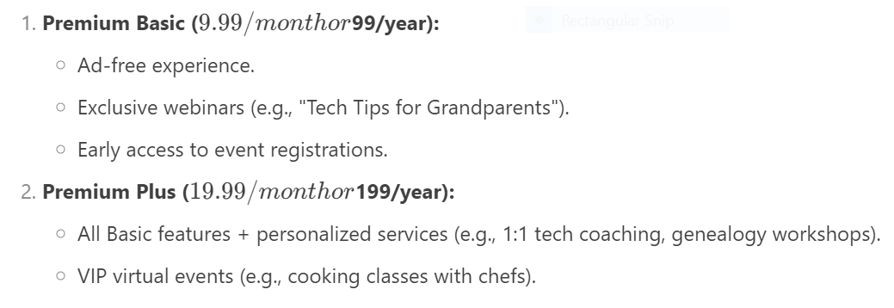Free Trials:
- 14-day Premium Basic trial (credit card required, easy cancellation).
Revenue Streams:
- Premium subscriptions (60% of revenue).
- Targeted ads (20%).
- Affiliate partnerships (e.g., discounts on photo books, 20%).

4. Marketing Strategy
Branding: Warm, inclusive visuals and messaging (e.g., tagline: “Your Second Home Online”).
Channels:
- Social media: Facebook/Instagram ads targeting grandparents.
- Content Marketing: Blog posts (“10 Fun Activities with Grandkids”), YouTube tutorials.
- Partnerships: Collaborate with AARP, toy brands, and genealogy platforms.
User Acquisition:
- Referral program: Free month of Premium for every friend who subscribes.
- Grandchild-driven campaigns: Encourage families to gift Premium memberships.
Retention Tactics:
- Weekly personalized emails with activity suggestions.
- “Grandparent of the Month” spotlight to foster community.

5. Operations Plan
Team:
- 2 Community Managers, 1 Content Creator, 1 Tech Support Specialist (remote team).
Tech Stack:
- Community platform: Mighty Networks (customizable, mobile-friendly).
- Payment processor: Stripe/PayPal.
- Analytics: Google Analytics + Mixpanel.
Content Calendar:
- Weekly: Articles on grandparenting tips.
- Monthly: Expert-led webinars (e.g., child psychology).
- Quarterly: Virtual grandparent-grandchild talent shows.

6. Financial Plan
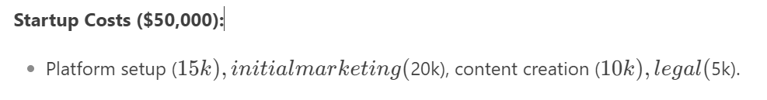Revenue Projections:
- Year 1: $60,000 (500 Premium subscribers + ads/affiliates).
- Year 2: $180,000 (1,500 subscribers + scaled partnerships).
Break-Even: Month 18.
Funding Needs: Seek $100,000 seed funding (50% equity, 50% grants).

7. Action Plan (12-Month Timeline)
Months 1–3:
- Finalize platform design and test beta with 100 users.
- Hire team and secure initial partnerships.
Months 4–6:
- Launch free tier with referral campaigns.
- Run Facebook ads targeting grandparents.
Months 7–9:
- Roll out Premium tiers with 14-day trials.
- Host first VIP event (e.g., “Virtual Travel with Grandkids”).
Months 10–12:
- Analyse user feedback; refine pricing tiers.
- Introduce annual subscription discounts.
KPIs:
- 10,000 free members, 5% conversion to paid, 70% trial-to-paid retention.
Risk Mitigation:
- If conversion lags: Offer limited-time discounts or add grandchild-friendly features.

